YouTube Hum aur Code
IDE NetBean
Roadmap
- Java basics
- OOP
- Collections
- Intro to Exception Handling
- Graphic user interface
- Java Database Connectivity
- Java graphics
- Socket Programming
- Multithreading
- Web Application Development
- Java servlets, etc
- DSA

Introduction
- As java is pure object-oriented programming language, everything in java is stored in classes
- Hence program starts with class
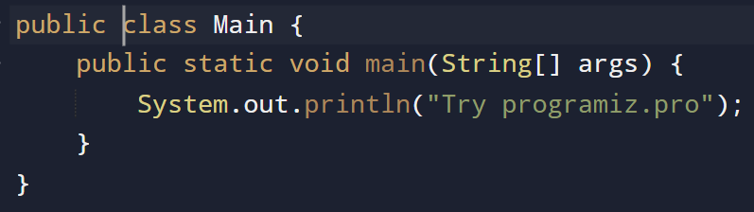
- File name == Class Name
- main() = function name
- void = keyword, no return value
- System.out.println() = output value

- Java is platform independent language
- As we create .java file after compiling program it creates .class file and this .class file can be executed everywhere (on any system)
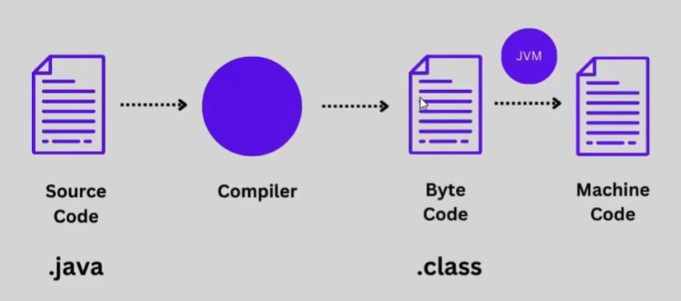

- JDK contains JVM which converts .class file in machine code
- Every system must have JVM to run .class file

Output

- Print
- Println
- \n = special character

Print
*
**
***
****
*****

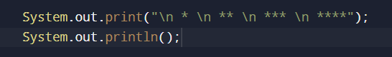

Variables

- Container for storing data values
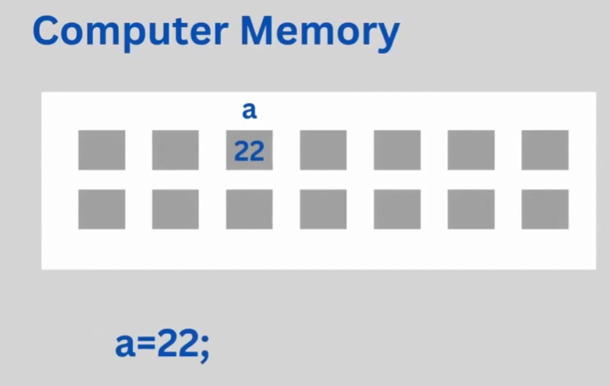
Has cell like boxes and inside any random cell we will store our values, variable is only our location hence keep it simple & understandable

Variable name
- Must start with letter, (_), $
- No spaces
- No reserved words
- Variable names are case sensitive

DataTypes
- Int
- Float
- Char
- Boolean
- String
Interview Questions
- Add 2 numbers
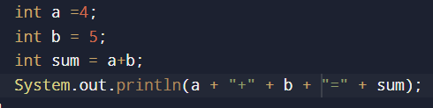
- Find reminder when one integer divides another
- Calculate average of 3 numbers
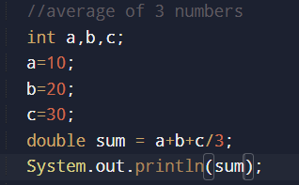
- Swap 2 numbers without using temporary variable
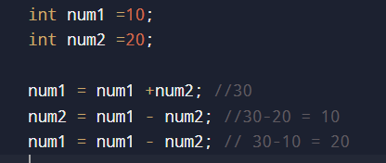

Type Casting
- Process or method that converts datatype into another datatype in both ways manually and automatically.
- Automatic done by compiler, manual done by programmer
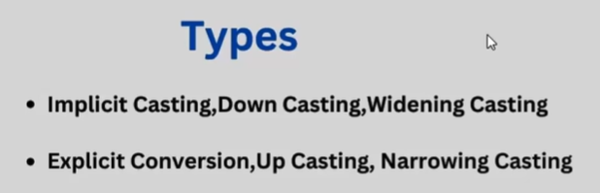
- Implicit Casting converting lower datatype into higher is called as widening type casting.
- It is done automatically, safe because there is no change to lose data
byte -> short -> char -> int -> long -> float -> double
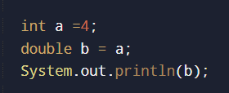

- Explicit Casting Converting upper datatype into lower datatype is called as narrowing
- It is done manually, not save, can lose data
- Explicit conversion or casting up.
- If we do not perform it manually, then compiler will give compile-time error
double-> float-> long-> int-> char-> short-> byte
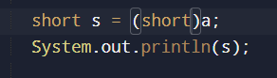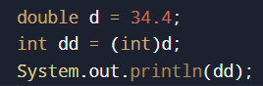

Input Scanner
Scanner class – Allows user to take input from console
- Import.java.util.*;
- Scanner sc = new Scanner(System.in);

- Util = package (like folder, contains different files)
- Scanner class = present in util package, used to take user input
- New = used to create object of Scanner class with name sc
- System.in = keyboard input

